Technical Sciences

УДК 004.942

Sagiyev A.S.
student
Kazakh-British Technical University
Polichshuk Y.V
student
Kazakh-British Technical University

MODELING DYNAMICS OF THE SUBPRIME
MORTGAGE CRISIS
Summary: The article studies a Systems Dynamics model for capturing the main interactions involved in the subprime mortgage crisis. The model provides two subsystems interconnection that related to each other relatively banking asset flow and house market. The differential equations are analyzed and simulated using Vensim PLE simulation software, which brings to the discussion of results.
Key words: system dynamics, financial crisis, subprime mortgage crisis.

Introduction

Home mortgage loans are widely used financial product in the world that are defined by real estate values. So it is important to measure the risk of each mortgage in order to reduce the risk banks or mortgage lenders ask for 10-20\% down payment of house value from borrowers. This creates an “equity buffer” that absorbs the first losses from home price declines. Drop in home values causes the value of this buffer to reduce that increase the risk to the lending institution, or to the bank. Everybody is influenced in World Financial Crisis. The crisis brings two gatherings of individuals: financier and owners of home. Homeowners speak to their home loans and investors speak to their cash. Mortgages speak to houses. Cash speaks to vast foundations like annuity assets, sovereign assets, common assets, and so on these gatherings are united to a budgetary framework where banks and representatives regularly known as Wall Street. These banks in Wall Street are firmly associated with houses in Main Street.

As an outcome of weight on capital, banks were worried about the size of future compose downs and counterparty risk. They have been attempting to keep however much money as could reasonably be expected as a pad against potential losses. They have been careful about loaning to each other and, subsequently, have been charging each other much higher interest rates than typical in the interbank loan markets [1]. This has led to a decrease in the availability of business loans and commercial credit that form the life cycle of the economy. As a result, a recessionary fall has implement on the economy that has led to lower consumption and higher unemployment. This has led to even higher underneath pressure on affordability at the level of individual families, thereby increasing the rate of defaults and leading to more foreclosures and further downward asset valuation in the banking sector.

Subprime mortgage crisis Modeling
In the model, an aggregated bank is assumed and it includes a portfolio of several classes of assets, and is in a healthy condition if total asset value is greater than its liability. Assets included in our model are Cash (A_{c}), Mortgage-Backed Assets (A_{m}) and Bank owned House Value (A_{h}). These three assets in flow and out flow form dynamics of banking asset flow. This banking asset model related with house market model and one dynamics in the first model influence to the dynamic behavior in the second model. In the figure below we can see the dynamics model of banking asset flow.
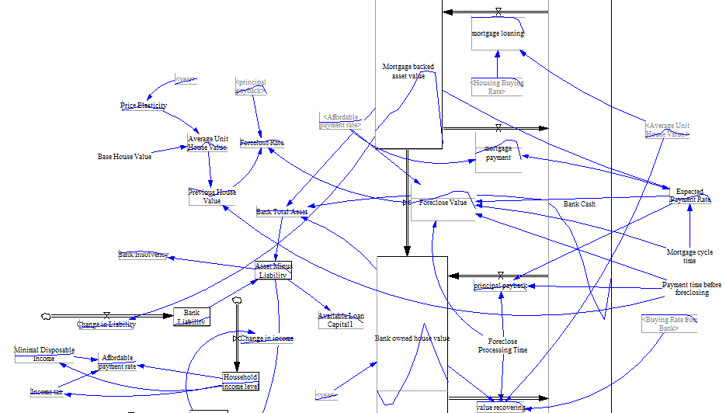
Figure 1 – System Dynamics Model of Bank Asset Flow
In the house market model we include three types of houses: the currently occupied houses (H_{o}), non-bank owned available houses (H_{n}) and bank owned houses (H_{b}). From the banking model we can include available loan capital (C_{a}) for house buyers in the house market model. Because of co-stream nature of this model with the banking system, the general formulation needs predictable. Case in point, bank loaning out rate in banking model is dictated by house-purchasing rate in house market model.
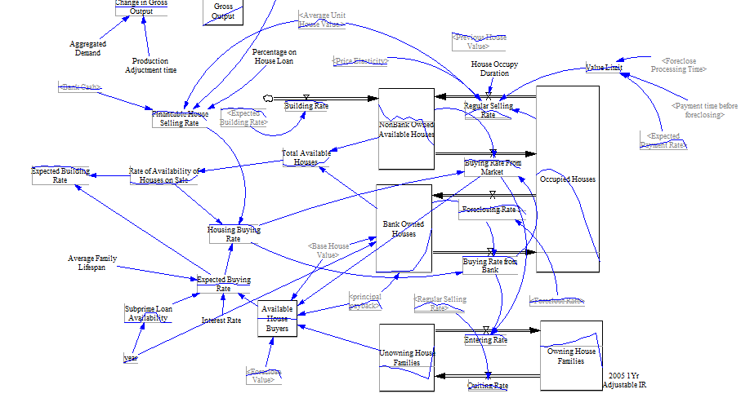
Figure 2- System Dynamics model for House market

Mathematical Model Description
In the scope of financial sector that is target system of our article there has been some limited work by using dynamic systems. For example, Garcia-Ochoa [2] develops a model to examination the dynamic behavior and feedback effect of borrower-lender relationship under regulation control. We suggest aggregate modeling that includes two main sub-systems: Banking system and House market system. We propose the mathematical equations which used in the model.
$\frac{dA_{m}}{dt}=P_{h}*R_{h}-\min\left(R_{a},R_{m}\right)-R_{f}, R_{m}=\frac{A_{m}}{T_{m}}$ (1)
$\frac{dA_{h}}{dt}=R_{f}+ R_{p}+ R_{hr}$ (2)
$\frac{dA_{c}}{dt}=\min\left(R_{a},R_{m}\right)-R_{h}*P_{h}+R_{hr}-R_{p}$ (3)
$C_{a}=\left(A_{t}-L\right)=\left(A_{c}+A_{m}+A_{h}-L\right)$ (4)
In the above 4 equation describe the model of banking asset flow. P_{h} in the equations denotes the price of houses, R_{f} – foreclosure rate, R_{m} – mortgage payment, R_{a} – affordable payment rate. R_{hr} is correspondingly stands for the value that transferred from A_{h} to Cash at the following rate.
$R_{av}=\frac{H_{av}}{T_{h}}$ (5)
$R_{fin}=\frac{r_{m}*min⁡(C_{a},A_{c})}{T_{h}*P_{h}}$ (6)
R_{av} describe the available houses on sale, where H_{av} is total available houses, T_{h} time constant associated with house buying. R_{fin} – buying rate as demand for the houses, r_{m} – portion of cash for the loan.

Results and Discussion

In the below figure we can see the result of model. We will see that, by utilizing subprime loan availability as a trigger, more purchasers would be pulled in towards obtaining houses. 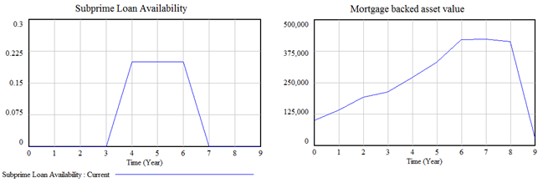
Figure 3- Subprime Loan Availability and Mortgage backed Asset Value

This will push the aggregate mortgage-backed esteem in the banking system higher, hence making the total expected mortgage payment higher than the total affordable payment. Thus, this prompts credit defaulting and foreclosure, which lead further to bring about, bank bankruptcy.

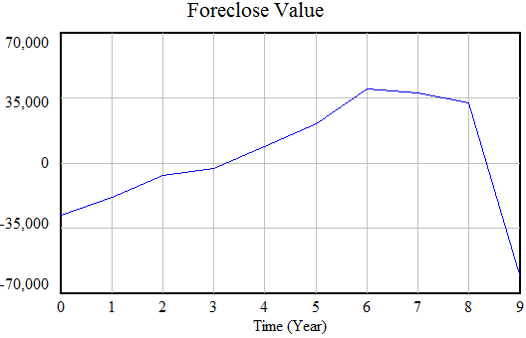
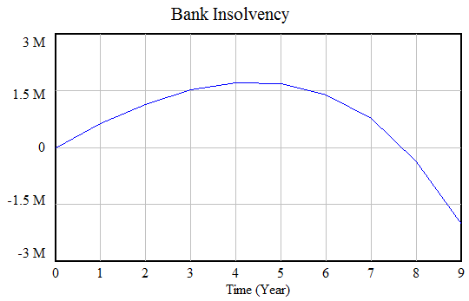
Figure 4- Foreclose value and Bank Insolvency

References
1. M.G. Crouhy, R.A. Jarrow and S.M. Turnbull, 2008, The Subprime Credit Crisis of 07, Social Sciences Research Network, http://www.ssrn.com.
2. F.G. Garcia-Ochoa, 1996, Reputation in Banking and Deposit Insurance: the Dynamics of Borrowing and Lending under Regulation. The 14thInternational Conference of the System Dynamics Society

